POWER BI DASHBOARD CHALLENGE
TASK 9 – FINAL DASHBOARD DESIGN & PUBLISHING
● Apply color themes, alignment, and storytelling flow.
● Add titles, legends, and tooltips for clarity.
● Publish the dashboard to GitHub / shared drive.
● ✅ Task: Produce a professional-quality dashboard.
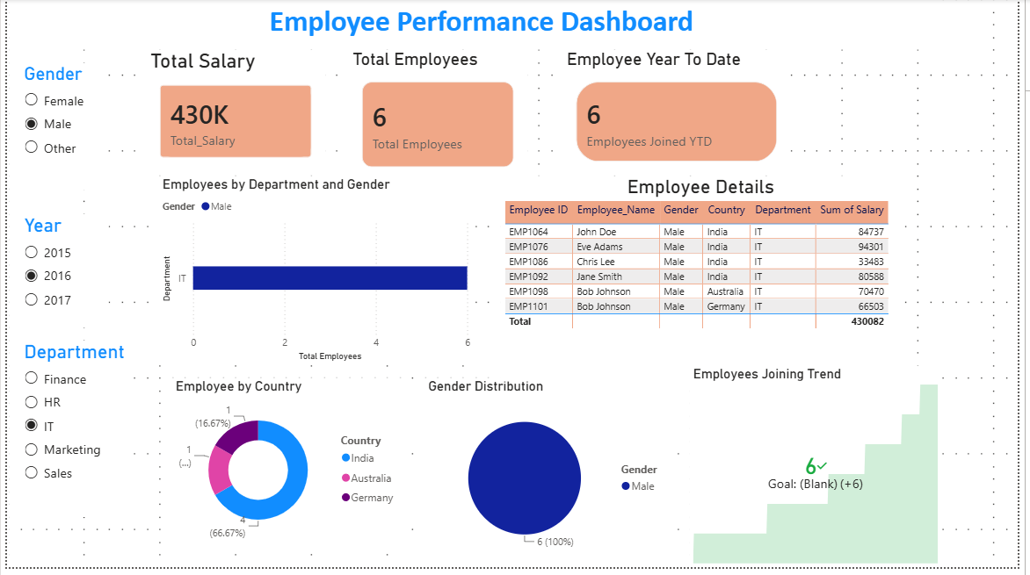
Observation
- Applied a consistent color theme across the dashboard.
- Improved the alignment and spacing of all visuals.
- Added clear and meaningful titles to each visual.
- Added legends wherever required for better understanding.
- Configured tooltips to provide additional information.
- Organized the visuals in a logical storytelling flow.
- Improved the overall readability and visual appearance of the dashboard.
- Checked the dashboard for blank, incorrect, or unclear values.
- Ensured that slicers and interactive features work properly.
- Finalized the dashboard and prepared it for publishing and presentation.

